Azure HDInsight - Big data processing using Hive on Azure HDInsight

# Overview

Azure HDInsight is the only fully-managed cloud Apache Hadoop offering that gives you optimized open-source analytic clusters for Spark, Hive, MapReduce, HBase, Storm, Kafka, and Microsoft R Server backed by a 99.9% SLA. Deploy these big data technologies and ISV applications as managed clusters with enterprise-level security and monitoring.

Hive is a data warehousing system that simplifies analyzing large datasets stored in Hadoop clusters, using SQL-Like language known as HiveQL. Hive converts queries to either map/reduce, Apache Tez or Apache Spark jobs.

To highlight how customers can efficiently leverage HDInsight Hive to analyze big data stored in Azure Blob Storage, this document provides an end-to-end walkthrough of analyzing a web transaction log of an imaginary book store using Hive.

After completing this lab, you will learn,

1. Different ways to execute hive queries on an HDInsight cluster
2. To use join, aggregates, analytic function, ranking function, group by and order by in Hive Query Language.

# Learn the basics of querying with Hive

### Launch Hive Views in Ambari portal

* + [https:// <FILL_ME_IN>/#/main/view/HIVE/auto_hive20_instance](https://pranavsparkbuildlab.azurehdinsight.net/#/main/view/HIVE/auto_hive20_instance)
  + Username: <FILL_ME_IN>
  + Password: <FILL_ME_IN>

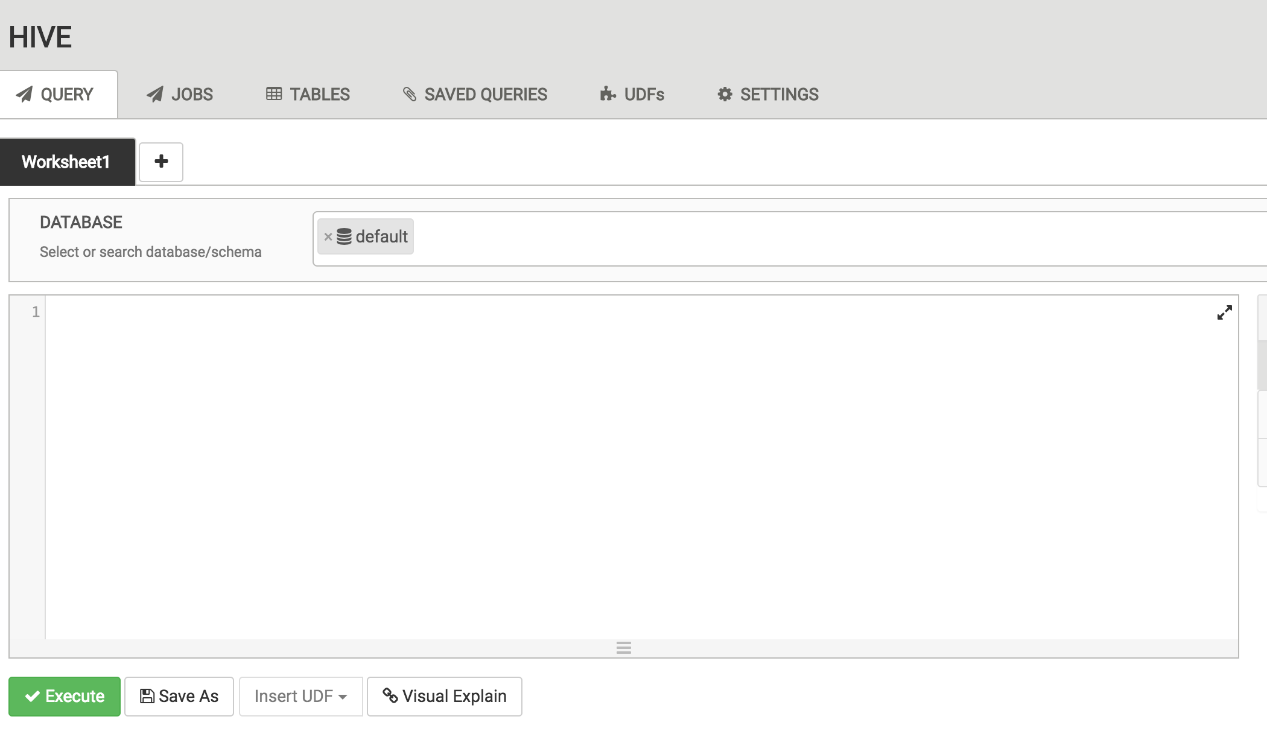

### Load Data into table

* + Copy and paste the following query in the **Query Editor***. Do not execute yet.*

DROP DATABASE IF EXISTS HDILABDB CASCADE;

CREATE DATABASE HDILABDB;

Use HDILABDB;

CREATE EXTERNAL TABLE IF NOT EXISTS weblogs(

TransactionDate varchar(50) ,

CustomerId varchar(50) ,

BookId varchar(50) ,

PurchaseType varchar(50) ,

TransactionId varchar(50) ,

OrderId varchar(50) ,

BookName varchar(50) ,

CategoryName varchar(50) ,

Quantity varchar(50) ,

ShippingAmount varchar(50) ,

InvoiceNumber varchar(50) ,

InvoiceStatus varchar(50) ,

PaymentAmount varchar(50)

) ROW FORMAT DELIMITED FIELDS TERMINATED by ',' lines TERMINATED by '\n'

STORED AS TEXTFILE LOCATION 'wasb:///hadooplabs/Lab1/weblogs/';

LOAD DATA INPATH 'wasb:///hadooplabs/Lab1/weblogs.csv' INTO TABLE HDILABDB.weblogs;

* + Click Execute to run the query. Once the query complete, the Query Process Results, status will change to **SUCCEEDED**.

### Select total count

* + Create a new Worksheet and execute the following query in the **Query Editor***.*

SELECT COUNT(*) FROM HDILABDB.weblogs;

The **Tez View** displays the summary of all the hive jobs executed on the Hadoop cluster.

### View the data

* + Create a new Worksheet and execute the following query in the **Query Editor***.*

SELECT * FROM HDILABDB.weblogs LIMIT 5;

### Where clause

* + Create a new Worksheet and execute the following query in the **Query Editor***.*

SELECT * FROM HDILABDB.weblogs WHERE orderid='107';

### 

### Find DISTINCT

* + Create a new Worksheet and execute the following query in the **Query Editor***.*

SELECT DISTINCT bookname FROM HDILABDB.weblogs WHERE orderid='107';

### GROUP BY

* + Create a new Worksheet and execute the following query in the **Query Editor***.*

SELECT bookname,COUNT(*) FROM HDILABDB.weblogs GROUP BY bookname;

### Analyse query using “Visual Explain”

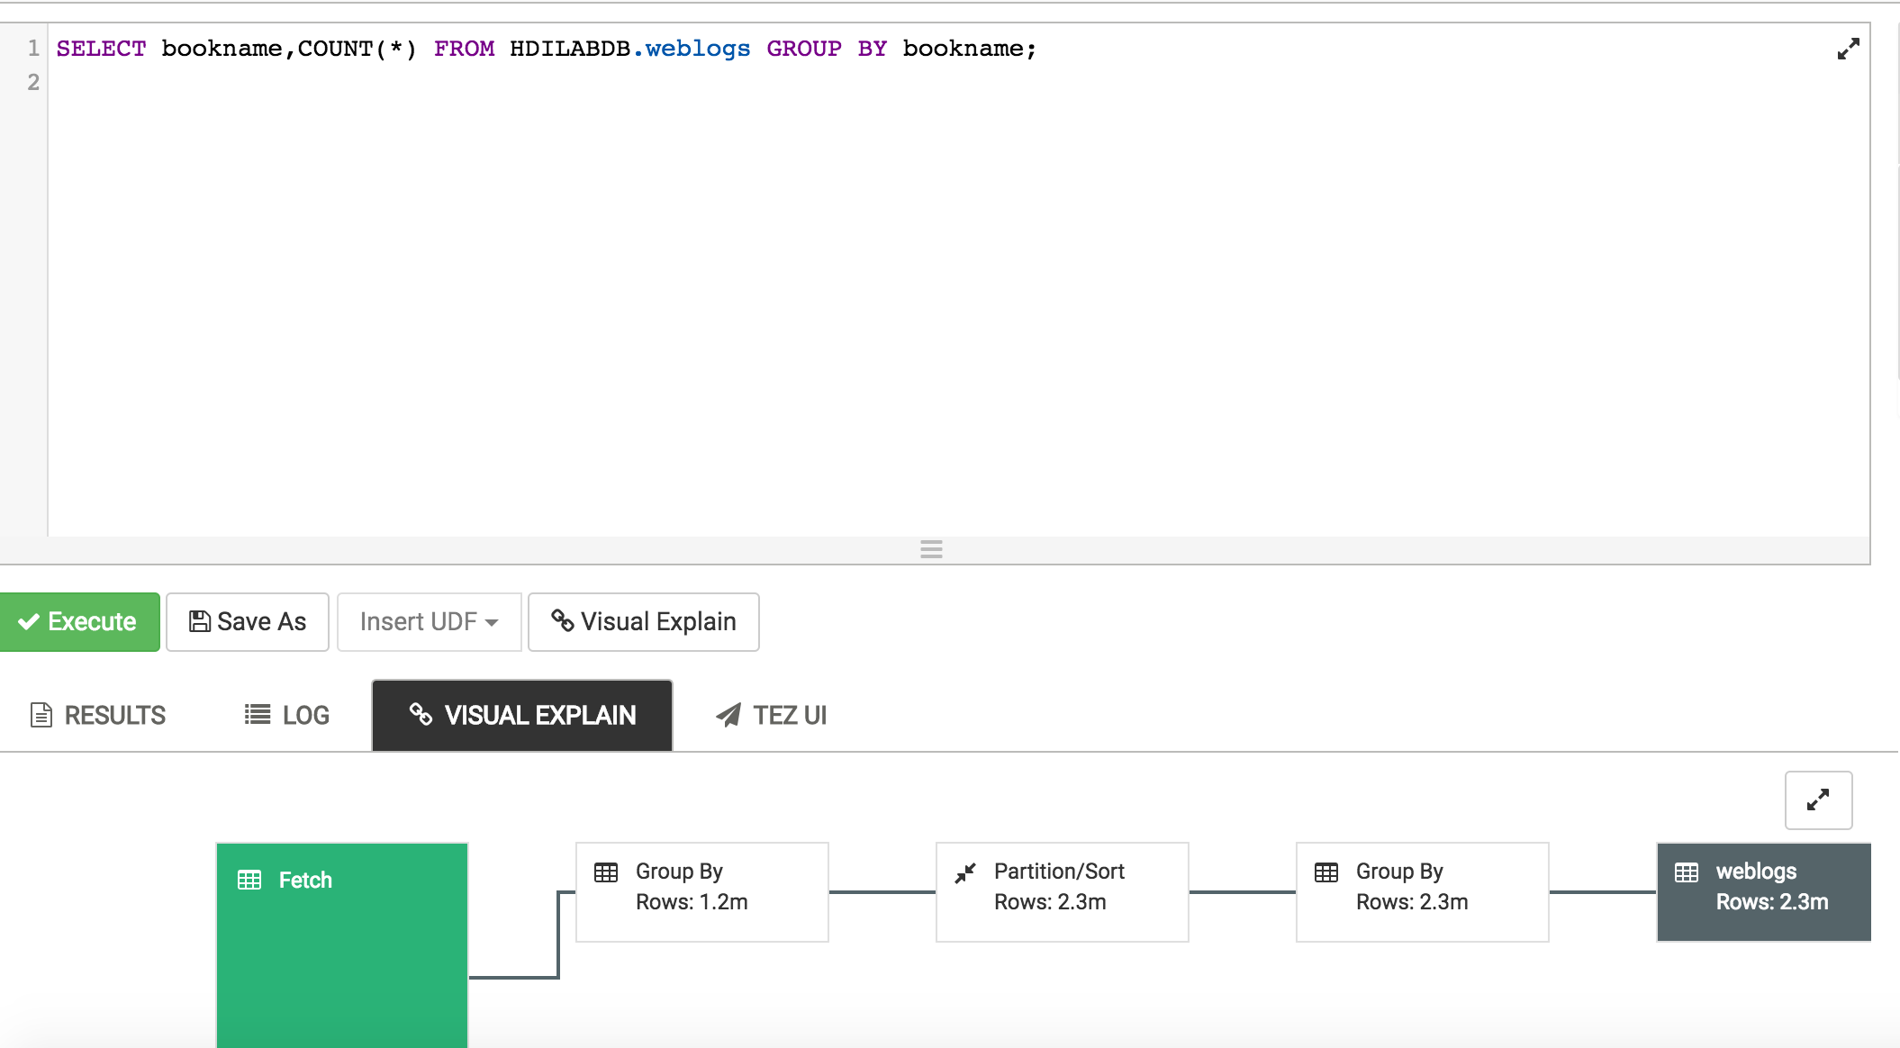

# Scenario 2 – Apply the basics

## Perform book store sales analysis

In this section, you’ll run hive queries to analyse the data in the weblogs table. The weblogs table contains transactional data of an imaginary online bookstore. You’ll have to analyse the sales data and prepare a sales report.

All analysis is based on the weblogs table, created earlier in the lab. The table description is given below

|  |  |
| --- | --- |
| **Column** | **Description** |
| TransactionDate | The date of the transaction |
| CustomerId | Unique Id assigned to the customer |
| BookId | Unique id assigned to a book in the book store |
| PurchaseType | **1**. **Purchased:** Customer bought the book  **2**. **Browsed:** Customer browsed but not purchased the book.  **3**. **Added to Cart:** Customer added the book to the shopping cart |
| TransactionId | Unique Id assigned to a transaction |
| OrderId | Unique order id |
| BookName | The name of the book accessed by the customer |
| CategoryName | The category of the book accessed by the customer |
| Quantity | Quantity of the book purchased. Valid only for PurchaseType = Purchased |
| ShippingAmount | Shipping cost |
| InvoiceNumber | Invoice number if a customer purchased the book |
| InvoiceStatus | The status of the invoice |
| PaymentAmount | Total amount paid by the customer. Valid only for PurchaseType = Purchased |

### Launch Hive Views in Ambari portal

* + [https:// <FILL_ME_IN>/#/main/view/HIVE/auto_hive20_instance](https://pranavsparkbuildlab.azurehdinsight.net/#/main/view/HIVE/auto_hive20_instance)
  + Username: <FILL_ME_IN>
  + Password: <FILL_ME_IN>

### Problem Statement #1

Write a query to return the total payment amount for each category per month. The output should look like this.

|  |  |  |
| --- | --- | --- |
| **CategoryName** | **QuantitySold** | **TotalAmount** |
| Drive_books | 211029 | 2064435 |
| Adventure | 112470 | 1022195 |
| World_History | 112263 | 1048990 |
| Art | 112105 | 1043190 |
| Non_Fiction | 111731 | 1046410 |
| Psychology | 111555 | 1024255 |
| Romance | 111316 | 1038265 |
| Automobile_books | 110017 | 1030720 |
| Philosophy | 109691 | 1042410 |
| Fiction | 109460 | 1032795 |
| Drama | 109246 | 1038565 |
| Management | 108262 | 1030805 |
| Programming | 108196 | 1013210 |
| Music | 108121 | 998930 |
| Cook | 108056 | 1051710 |
| Science | 107706 | 1063445 |
| Religion | 107513 | 999780 |
| Political | 106000 | 1034820 |

#### Create a new Worksheet and execute the following query in the Query Editor.

-- Get top Selling Categories

DROP TABLE IF EXISTS HDILABDB.SalesbyCategory;

CREATE TABLE HDILABDB.SalesbyCategory ROW FORMAT DELIMITED

FIELDS TERMINATED by '\1' lines TERMINATED by '\n'

STORED AS TEXTFILE LOCATION 'wasb:///hadooplabs/Lab1/SalesbyCategory'

AS

Select

categoryname,

Sum(Quantity) As quantitysold,

Sum(PaymentAmount) As totalamount

FROM HDILABDB.weblogs

WHERE PurchaseType="Purchased"

GROUP BY **CategoryName**

ORDER BY QuantitySold Desc;

Select * from HDILABDB.SalesbyCategory LIMIT 10

### Problem Statement #2

Write a query to return the total payment amount and the total quantity sold per book. The output should look like this.

|  |  |  |
| --- | --- | --- |
| **BookName** | **QuantitySold** | **TotalAmount** |
| The voyages of Captain Cook | 232414 | 2194890 |
| Advances in school psychology | 231410 | 2193740 |
| Science in Dispute | 231408 | 2168425 |
| History of political economy | 231255 | 2190040 |
| THE BOOK OF WITNESSES | 230872 | 2145540 |
| The adventures of Arthur Conan Doyle | 230023 | 2191910 |
| Space fact and fiction | 229908 | 2171820 |
| New Christian poetry | 228849 | 2185845 |
| Understanding American politics | 228598 | 2182720 |

#### Create a new Worksheet and execute the following query in the Query Editor.

-- Top Selling Books

DROP TABLE IF EXISTS HDILABDB.SalesbyBooks;

CREATE TABLE HDILABDB.SalesbyBooks ROW FORMAT DELIMITED FIELDS

TERMINATED by '\1' lines TERMINATED by '\n'

STORED AS TEXTFILE LOCATION 'wasb:///hadooplabs/Lab1/SalesbyBooks'

AS

Select

BookName,

Sum(Quantity) As QuantitySold,

Sum(PaymentAmount) As TotalAmount

FROM HDILABDB.weblogs

WHERE PurchaseType='Purchased'

GROUP BY BookName

ORDER BY QuantitySold Desc;

Select * from HDILABDB.SalesbyBooks LIMIT 10

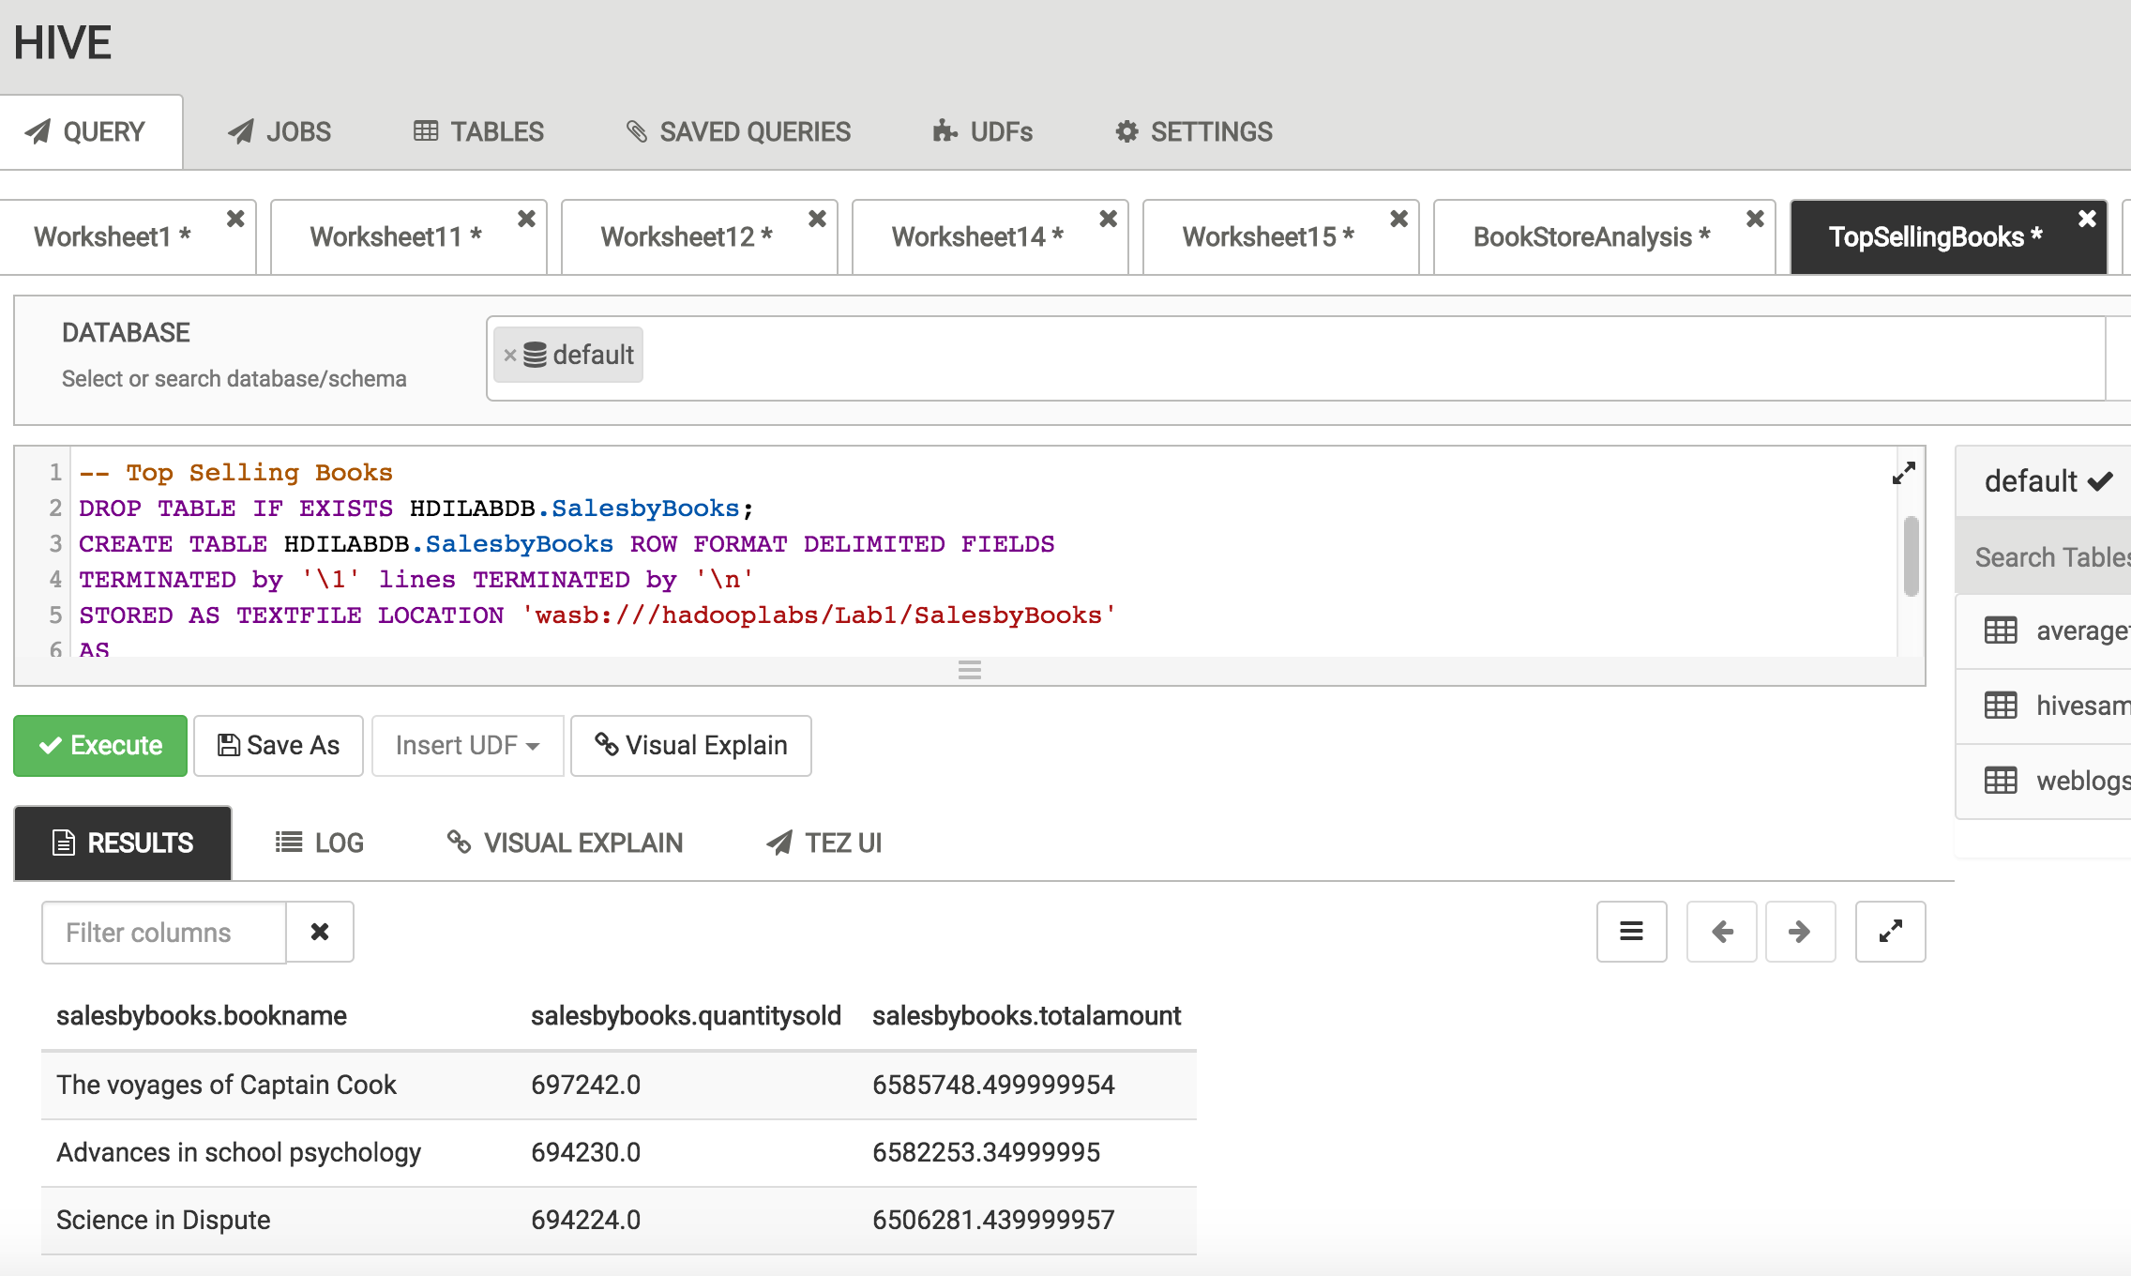

### Problem Statement #3

Write a query to return the top 3 books browsed by the customers who also browsed the book, **THE BOOK OF WITNESSES**. Your output should look like this

|  |  |
| --- | --- |
| **BookName** | **cnt** |
| New Christian poetry | 9445 |
| History of political economy | 9384 |
| Science in Dispute | 9367 |

#### Create a new Worksheet and execute the following query in the Query Editor.

DROP TABLE IF EXISTS HDILABDB.customerswhobrowsedxbook;

CREATE TABLE HDILABDB.customerswhobrowsedxbook ROW FORMAT DELIMITED

FIELDS TERMINATED by '\1' lines TERMINATED by '\n'

STORED AS TEXTFILE LOCATION 'wasb:///hadooplabs/Lab1/customerswhobrowsedxbook'

AS

With Customerwhobrowsedbookx as

(

SELECT distinct customerid

from weblogs

WHERE PurchaseType="Browsed"

and BookName="THE BOOK OF WITNESSES"

)

SELECT w.BookName,count(*) as cnt from HDILABDB.weblogs w

JOIN Customerwhobrowsedbookx cte

on w.CustomerId=cte.CustomerId

WHERE w.PurchaseType="Browsed"

AND w.BookName Not in ("THE BOOK OF WITNESSES")

group by w.bookname having count(*)>10

order by cnt desc

LIMIT 3;

Select * from HDILABDB.customerswhobrowsedxbook LIMIT 10

# Learn more and get help

* [Azure HDInsight Overview](https://azure.microsoft.com/en-us/services/hdinsight/)
* [Getting started with Azure HDInsight](https://docs.microsoft.com/en-us/azure/hdinsight/)
* [Use Hive on HDInsight](https://docs.microsoft.com/en-us/azure/hdinsight/hdinsight-hadoop-linux-tutorial-get-started)
* [Use Spark on HDInsight](https://docs.microsoft.com/en-us/azure/hdinsight/hdinsight-apache-spark-overview)
* [Use Interactive Hive on HDInsight](https://docs.microsoft.com/en-us/azure/hdinsight/hdinsight-hadoop-use-interactive-hive)
* [Use HBase on HDInsight](https://docs.microsoft.com/en-us/azure/hdinsight/hdinsight-hbase-overview)
* [Use Kafka on HDInsight](https://docs.microsoft.com/en-us/azure/hdinsight/hdinsight-apache-kafka-introduction)
* [Use Storm on HDInsight](https://docs.microsoft.com/en-us/azure/hdinsight/hdinsight-storm-overview)
* [Use R Server on HDInsight](https://docs.microsoft.com/en-us/azure/hdinsight/hdinsight-hadoop-r-server-overview)
* [Open Source component guide on HDInsight](https://docs.microsoft.com/en-us/azure/hdinsight/hdinsight-component-versioning#hadoop-components-available-with-different-hdinsight-versions)
* [Extend your cluster to install open source components](https://docs.microsoft.com/en-us/azure/hdinsight/hdinsight-hadoop-customize-cluster-linux#support-for-open-source-software-used-on-hdinsight-clusters)
* [HDInsight release notes](https://docs.microsoft.com/en-us/azure/hdinsight/hdinsight-release-notes)
* [HDInsight versioning and support guidelines](https://docs.microsoft.com/en-us/azure/hdinsight/hdinsight-component-versioning#supported-hdinsight-versions)
* [How to upgrade HDInsight cluster to a new version](https://docs.microsoft.com/en-us/azure/hdinsight/hdinsight-upgrade-cluster)
* [Ask HDInsight questions on stackoverflow](https://stackoverflow.com/questions/tagged/hdinsight)
* [Ask HDInsight questions on Msdn forums](https://social.msdn.microsoft.com/forums/azure/en-us/home?forum=hdinsight)